Assignment 2: Grew pattern-based search exercise: <http://match.grew.fr/>

**Computational Syntax**

**Julen Etxaniz**

Define rules to detect the following elements:

* Who write what:
  + (UD_English-EWT@2.9) Darin Fisher wrote this response on January 25, 2005.
  + (UD_English-GUM@2.9) Montalvo is holding a copy of the book Blown for Good critical of Scientology, written by Marc Headley.
* Who find what:
  + (UD_English-Atis@2.9)  could you find me the cheapest fare from boston to san francisco
* Think of a pattern(s) of your interest, write rules to detect it and present the examples found.
* Hint: to write the search patterns, it will be necessary to first draw the dependency trees using udpipe: <https://lindat.mff.cuni.cz/services/udpipe/>
* To collect results, you can use the "Export" option (select the "pivot" or element around which the given patterns will be arranged)

# Who write what

## (UD_English-EWT@2.9) Darin Fisher wrote this response on January 25, 2005.

First, we draw the dependency tree using udpipe. We can see the dependencies and tags we must use in the pattern.

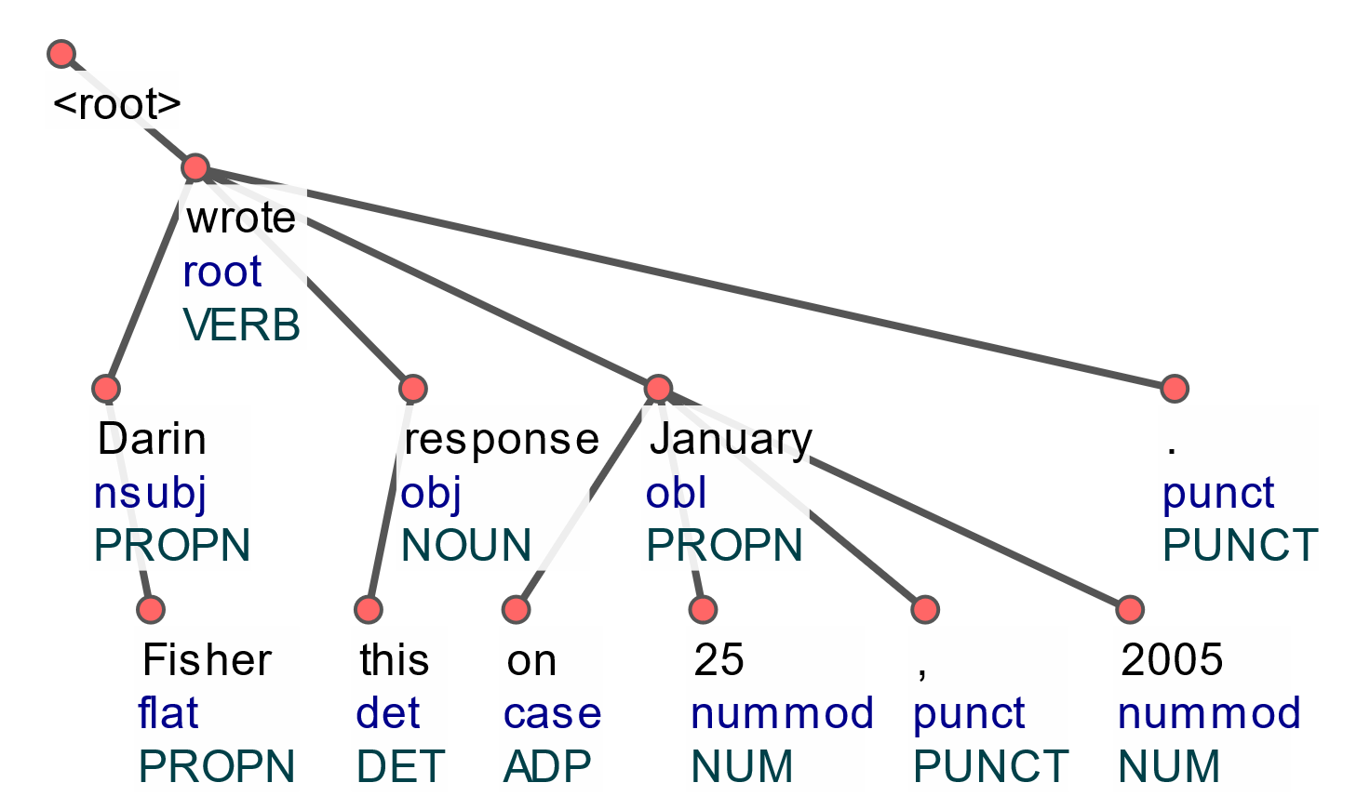

We can also export the sentence in conllu format and import it as a table.

|  |  |  |  |  |  |  |  |  |  |
| --- | --- | --- | --- | --- | --- | --- | --- | --- | --- |
| Id | Form | Lemma | UPosTag | XPosTag | Feats | Head | DepRel | Deps | Misc |
| 1 | Darin | Darin | PROPN | NNP | Number=Sing | 3 | nsubj | _ | TokenRange=0:5 |
| 2 | Fisher | Fisher | PROPN | NNP | Number=Sing | 1 | flat | _ | TokenRange=6:12 |
| 3 | wrote | write | VERB | VBD | Mood=Ind|Tense=Past|VerbForm=Fin | 0 | root | _ | TokenRange=13:18 |
| 4 | this | this | DET | DT | Number=Sing|PronType=Dem | 5 | det | _ | TokenRange=19:23 |
| 5 | response | response | NOUN | NN | Number=Sing | 3 | obj | _ | TokenRange=24:32 |
| 6 | on | on | ADP | IN | _ | 7 | case | _ | TokenRange=33:35 |
| 7 | January | January | PROPN | NNP | Number=Sing | 3 | obl | _ | TokenRange=36:43 |
| 8 | 25 | 25 | NUM | CD | NumType=Card | 7 | nummod | _ | SpaceAfter=No|TokenRange=44:46 |
| 9 | , | , | PUNCT | , | _ | 7 | punct | _ | TokenRange=46:47 |
| 10 | 2005 | 2005 | NUM | CD | NumType=Card | 7 | nummod | _ | SpaceAfter=No|TokenRange=48:52 |
| 11 | . | . | PUNCT | . | _ | 3 | punct | _ | SpaceAfter=No|TokenRange=52:53 |

We define the pattern based on the tree and test it in grew. We get 20 occurrences of the pattern with our search. We can find the example sentence in the third position. We can see the whole dependency tree below. We can also export the sentences to a TSV file and import this file to a table.

pattern {

VERB -[nsubj]-> SUBJ;

VERB -[obj]-> OBJ;

VERB [lemma = "write"];

}

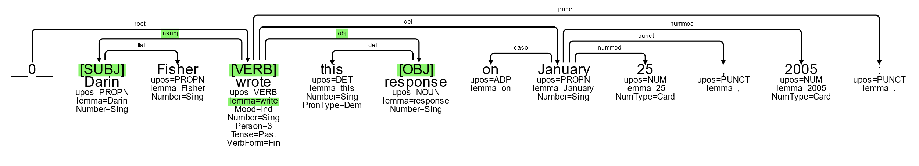

|  |  |  |
| --- | --- | --- |
| left_context | pivot | right_context |
| " | They | can freely write anything they like about our prophet, but if one raises doubts about the Holocaust he is either fined or sent to prison, he added. |
|  | One | of the Wesley boys wrote the hymn. |
|  | Darin | Fisher wrote this response on January 25, 2005: |
| Currently, | I | am writing a book on natural supplements to aid weight loss, with Harry Preuss, MD, a Professor of Medicine at Georgetown University; it is scheduled for publication by Broadway (Random House) in January 2007. |
|  | I'm | writing an essay for school and I need to know if the iPhone was the first Smart Phone. |
| Be more careful when | you | write reviews- this is an accounting group, not Hollister the clothing store. |
| I know its in the wrong catagory, but still, | I | wrote this question for a reason, not for you to critisize me. |
| I think it is mine but I forgot to write it in the blue FX book ( | I | only wrote it in my red book). |
| Sorry | I | haven't written you guys in a while to keep you properly updated. |
|  | I | have written a lot recently about healing the self so today here are a few words on healing our collective body, mind and soul. |
|  | I | am writing you in absolute confidence primarily to seek your assistance in acquiring oil funds that are presently trapped in the republic of Iraq. |
| The main reason | I | wrote this post is to ask anyone reading this if they know of some way I can help put a stop to this Cat Holocaust. |
| In 1594 | PEREZ | wrote & published a book under the assumed name of "RAPHAEL PEREGRINO." |
| 1561 | Ruy | Lopez writes his book on chess. |
| Lopez addressed the note which | I | had written, sealed it with his sleeve-link, and sent it by the hand of the servant, Jose. |
| Hello my name is Vera and | I'm | writing a review about my own counseling practice in Bellevue, WA. and in Renton WA. |
|  | I | normally don't write reviews but seeing that I considered Dillards a distinguished, upscale place to shop, this one won't be getting my business, nor my family's , nor my co-workers. |
| The excellent windows have performed without any problems, but that's not why | I'm | writing my review. |
|  | I | rarely write reviews such as this one, but they certainly deserve anyone's business! |
| The worst thing that can happen for any restaurant like Zahav is to have too many | people | write hyperbolic reviews making claims that "everyone" is going to "love" the food, decor and service. |

## (UD_English-GUM@2.9) Montalvo is holding a copy of the book Blown for Good critical of Scientology, written by Marc Headley.

First, we draw the dependency tree using udpipe. We can see the dependencies and tags we must use in the pattern.

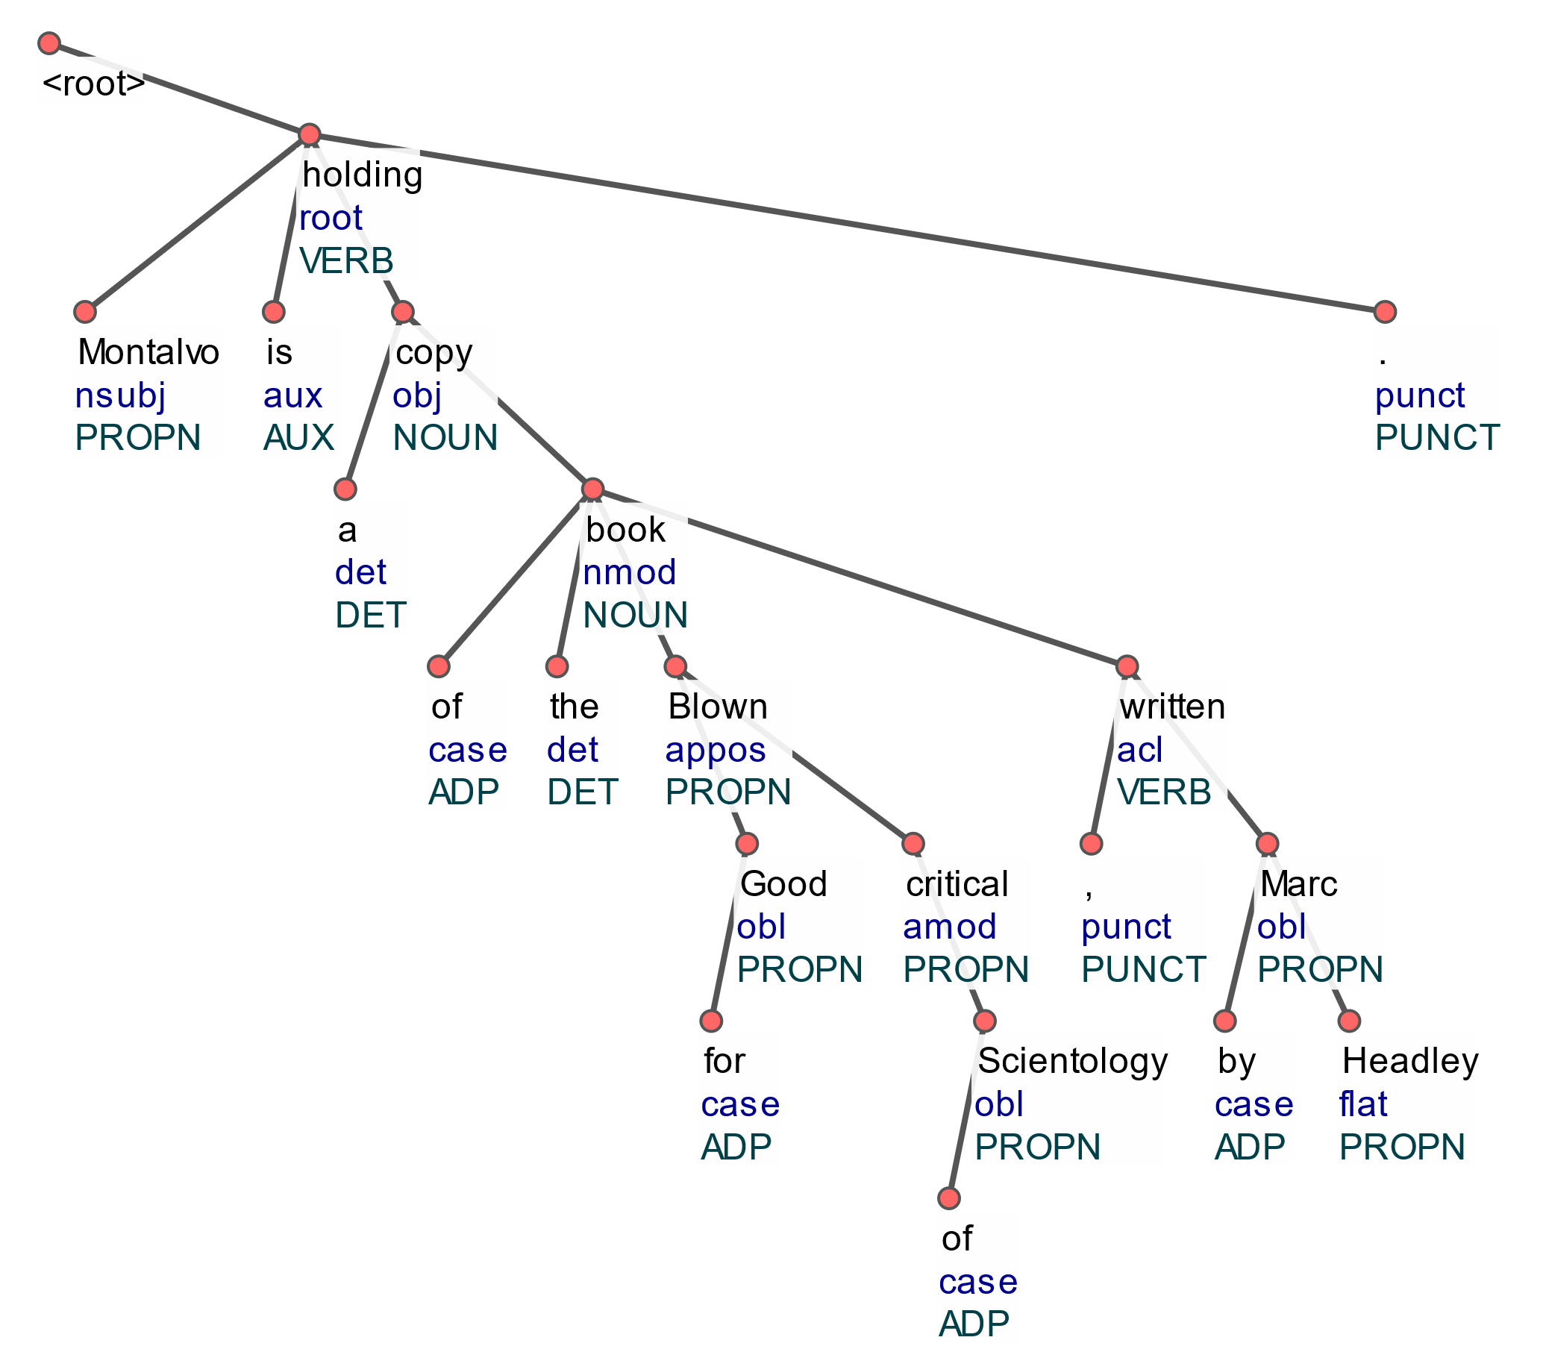

We define the pattern based on the tree and test it in grew. We get 5 occurrences of the pattern with our search. We can find the example sentence in the third position. We can see the whole dependency tree below.

pattern {

OBJ -[acl]-> VERB;

VERB -[obl]-> OBL;

VERB [lemma = "write"];

}



# Who find what

## (UD_English-Atis@2.9) could you find me the cheapest fare from boston to san Francisco

First, we draw the dependency tree using udpipe. We can see the dependencies and tags we must use in the pattern.

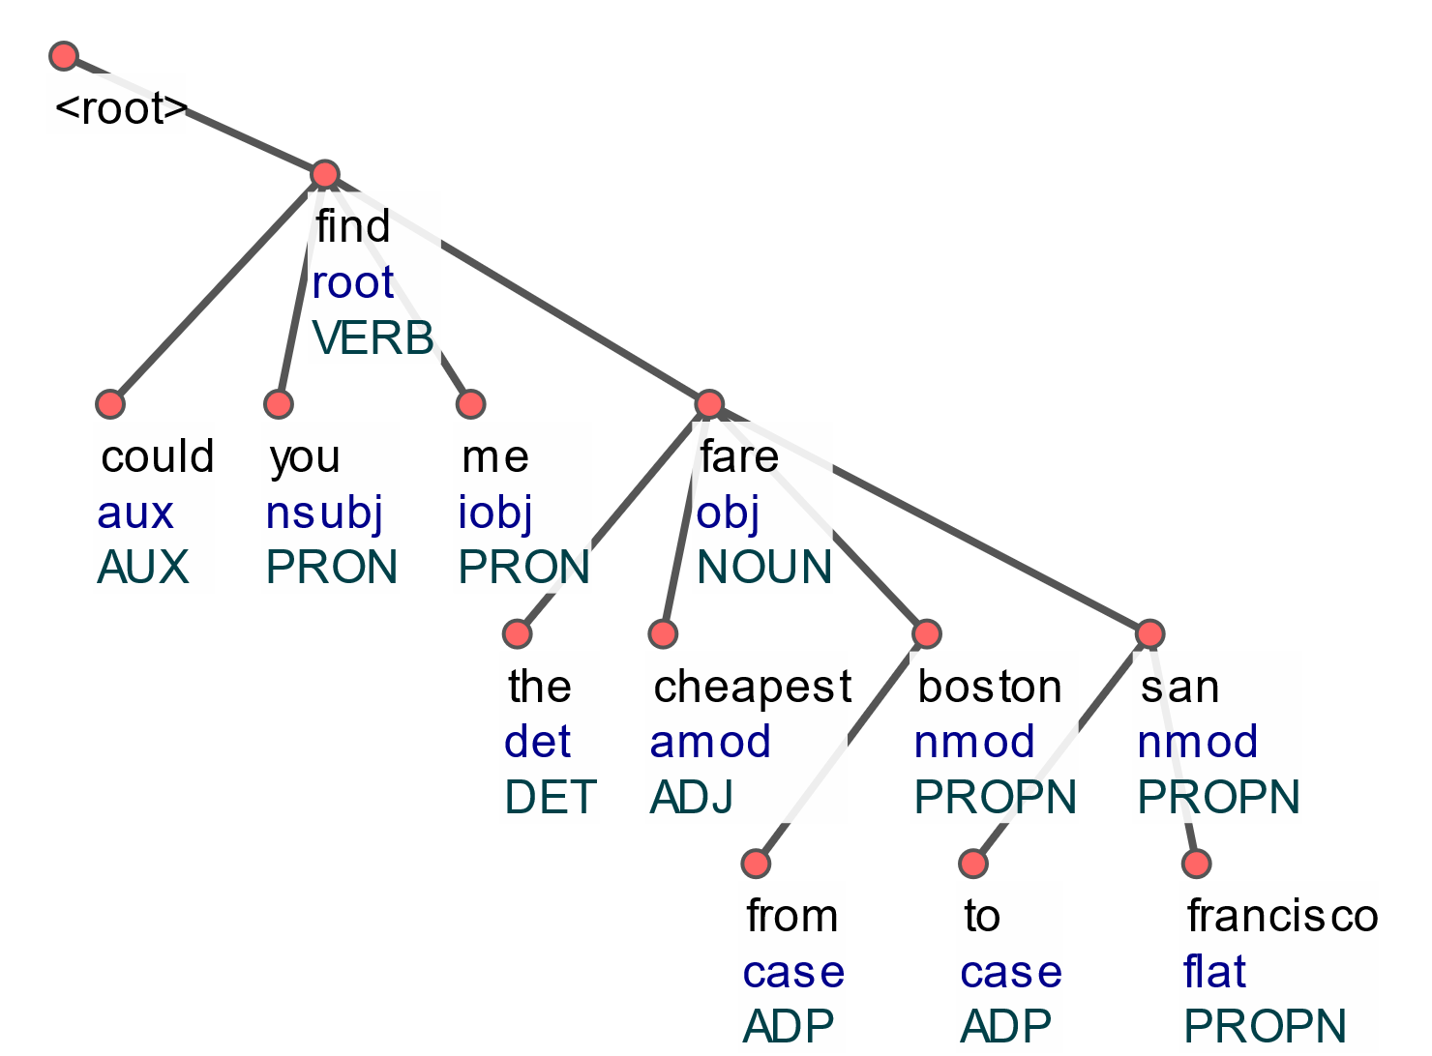

We define the pattern based on the tree and test it in grew. We get 13 occurrences of the pattern with our search. We can find the example sentence in the 5th position. We can see the whole dependency tree below.

pattern {

VERB -[nsubj]-> SUBJ;

VERB -[obj]-> OBJ;

VERB [lemma = "find"];

}

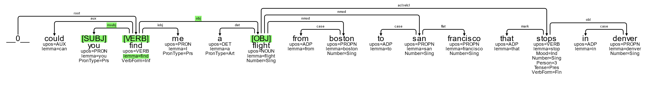

# Who lose what

## (UD_English-EWT@2.9) Today's incident proves that Sharon has lost his patience and his hope in peace.

First, we draw the dependency tree using udpipe. We can see the dependencies and tags we must use in the pattern.

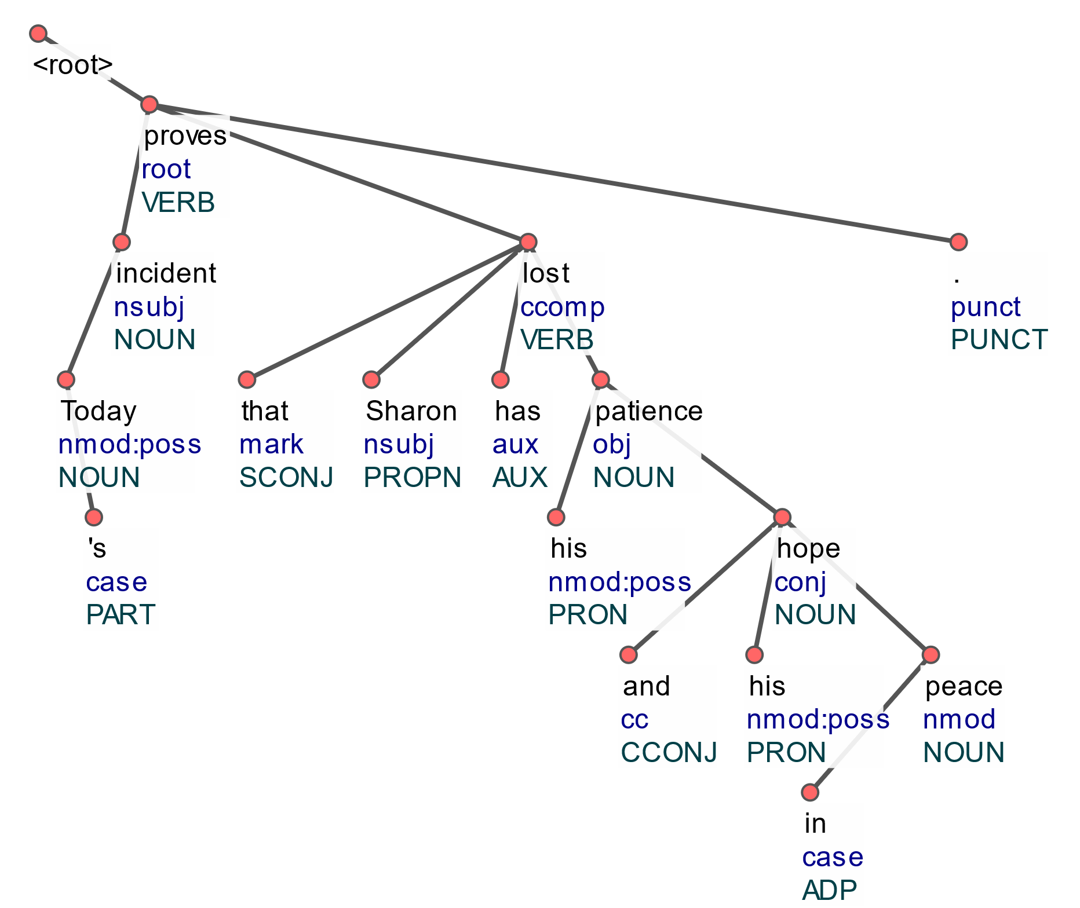

We define the pattern based on the tree and test it in grew. We get 21 occurrences of the pattern with our search. We can find the example sentence in the first position. We can see the whole dependency tree below.

pattern {

VERB -[nsubj]-> SUBJ;

VERB -[obj]-> OBJ;

VERB [lemma = "lose"];

}

